**Name:** Alec Mabhiza Chirawu

**Student ID:** M202161029

**Course:** Digital communications

**Assignment 1:** What is Fourier transform? **(*Briefy summary*)**

**Fourier Transform** is a tool that breaks a waveform (a function or signal) into an alternate representation, characterized by the sine and cosine functions of varying frequencies. The Fourier Transform shows that any waveform can be re-written as the sum of sinusoidals.

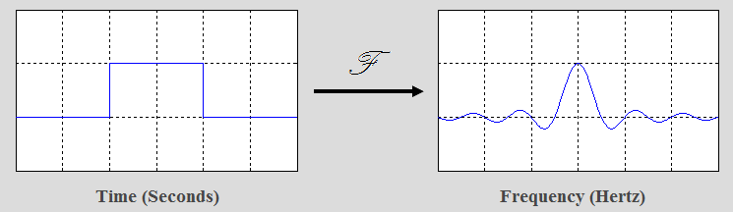

**Convolution Property of the Fourier Transform**

The convolution of two functions in time is defined by:

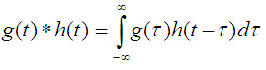

The Fourier Transform of the convolution of g(t) and h(t) [with corresponding Fourier Transforms G(f) and H(f)] is given by:

F{g(t)*h(t)} = G(f)H(f)

**Fourier Series**

It breaks down a periodic function into the sum of sinusoidal functions. It is the fourier transform for periodic functions, where a periodic function is defined by:

F(t+T) = f(t)

Periodic square waveform

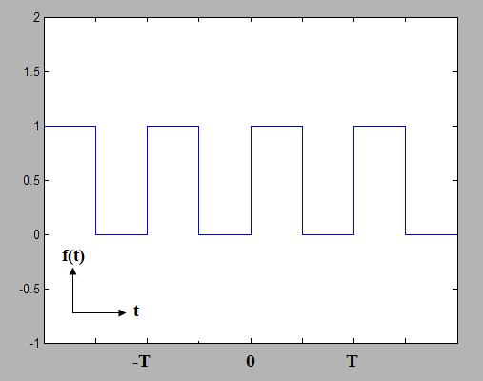

* A fourier series is defined with period T which is an infinite sum of sinusoidal functions(cosine and sine).
* Each have frequency that is an integer multiple of (1/T) which is the inverse of the fundamental period.

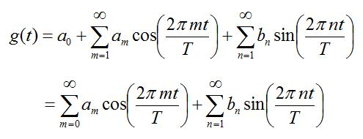

Where: a_m, b_n are the coefficients of the fourier series.

Expansion 1:

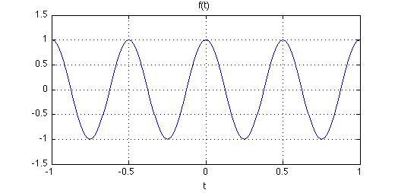

Encrementing expansion of (1/T) on sine series odd numbers 1,3,5,7,….

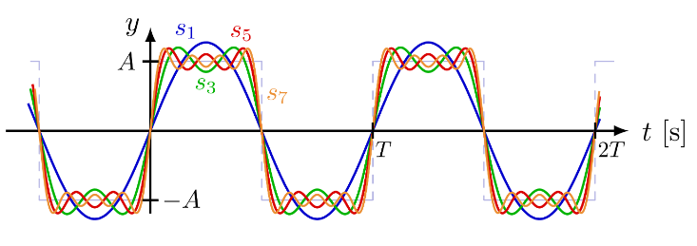

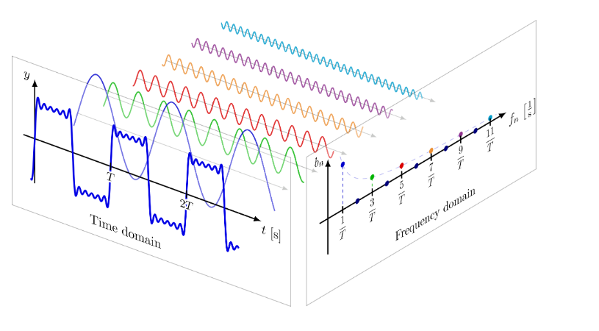

At 7th expansion square or rectangle wave form is formed.

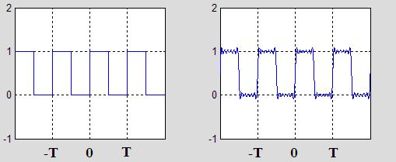

A fundamental lesson can be learned from above , the wider the square pulse produces a narrower , more constrained spectrum which is the fourier transform. Rapidly changing functions require more high frequency content and the functions that are moving more slowly in time will have less high frequency energy.